**FOR CLIENTS AND TRAINERS**

1. The signup page contains a button at the very end called **Forgot Password.** Click on it.

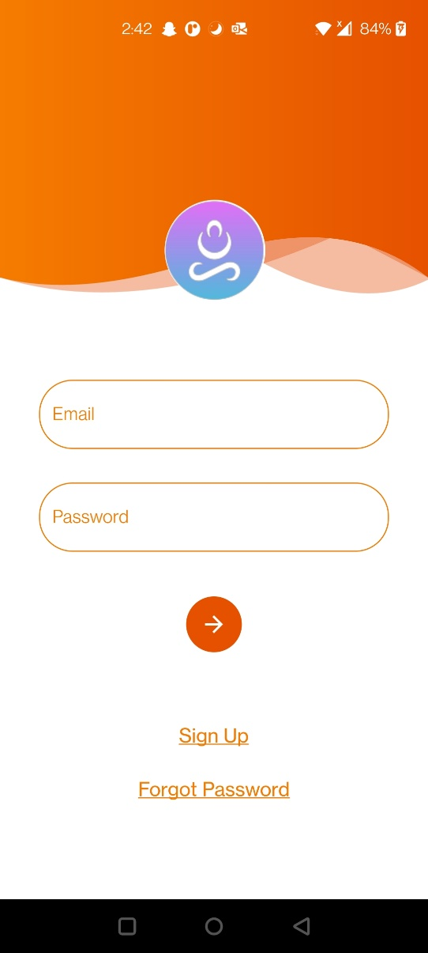

1. This will take you to another page where you can enter your email. Here enter your email and click the arrow. It will send a message stating the link has been sent.

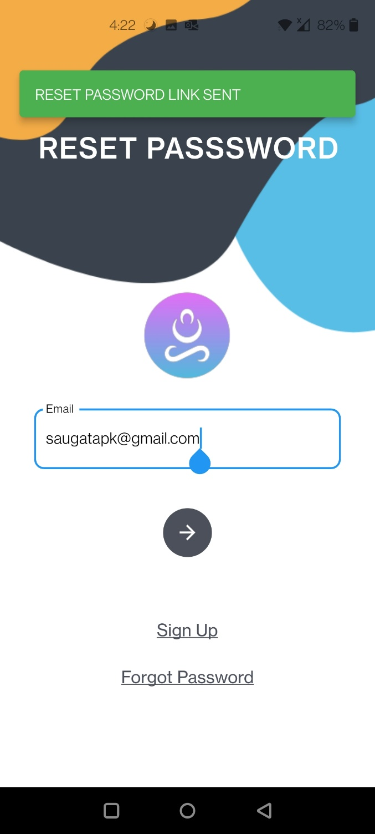

1. Check your email and find the email with the link to reset your password.

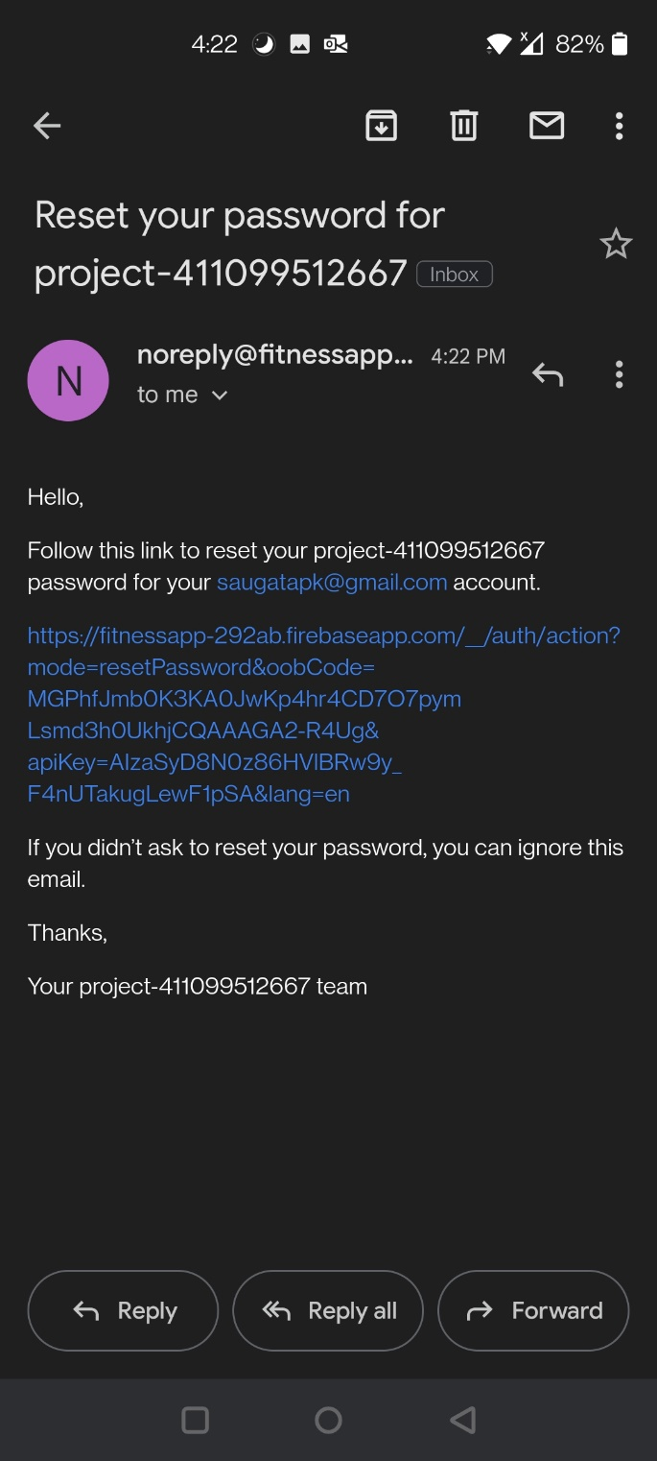

1. Clicking on the link will take you to another page where you can enter your new password.

